

2.Teaching–Learning and Pedagogy Policy
1. Purpose
To establish a structured, student-centric, and outcome-oriented teaching–learning framework that ensures effective curriculum delivery through innovative pedagogy, ICT integration, and inclusive academic practices in alignment with UGC guidelines and NAAC quality benchmarks.
2. Scope
This policy applies to all undergraduate and postgraduate programmes, faculty members, and departments of the institution.
3. Objectives
- To promote Outcome-Based Education (OBE) and student-centric learning
- To ensure effective and timely curriculum delivery
- To integrate ICT-enabled and blended learning practices
- To support diverse learners, especially rural and first-generation students
- To enhance critical thinking, problem-solving, and employability skills
- To ensure continuous improvement in teaching quality
4. Policy Guidelines
4.1 Teaching Framework
- Teaching shall be aligned with CBCS and OBE principles
- Faculty shall define and communicate Course Outcomes (COs) at the beginning of each semester
- Teaching shall be based on approved lesson plans and academic plans
4.2 Student-Centric Pedagogy
Faculty shall adopt:
- Experiential learning (projects, field work)
- Participative learning (group discussions, seminars)
- Problem-solving and case-based learning
- Peer and collaborative learning methods
4.3 ICT-Enabled Teaching
- Use of ICT tools such as LMS, Google Classroom, PPTs, videos, and e-content
- Adoption of blended learning (offline + online)
- Use of digital resources including e-books and online lectures
4.4 Inclusive Teaching Practices
- Conduct of bridge courses for first-year students
- Remedial coaching for slow learners
- Advanced learning opportunities for high achievers
- Special support for rural and first-generation learners
4.5 Skill and Value Integration
- Integration of communication skills, life skills, and employability skills
- Promotion of value-based and ethical education
- Encouragement of project-based and experiential learning
5. Implementation Mechanism
5.1 Academic Planning
- IQAC prepares the Institutional Academic Calendar
- Departments conduct academic planning meetings before each semester
5.2 Teaching Execution
- Faculty prepare and maintain:
  - Lesson Plans
  - Course Files
  - Teaching Diaries
- Teaching shall be delivered using interactive and ICT-enabled methods
5.3 Student Induction
- Orientation and bridge programmes shall be conducted for first-year students
5.4 Assessment Practices
- Continuous Internal Assessment (CIA) shall include:
  - Tests
  - Assignments
  - Seminars
  - Presentations
- Semester-end examinations shall be conducted as per university norms
5.5 Oversight
- The Principal and IQAC shall monitor the teaching–learning process
- Heads of Departments shall review syllabus coverage and teaching effectiveness
6. Teaching–Learning Process Flow
Planning → Delivery → Assessment → Feedback → Improvement
- Planning: Academic calendar, lesson plans
- Delivery: Classroom + ICT-enabled teaching
- Assessment: Internal + external evaluation
- Feedback: Student and stakeholder input
- Improvement: Corrective measures and innovation
7. Monitoring and Evaluation
7.1 Academic Monitoring
- Verification of lesson plans, course files, and teaching diaries
- Monitoring of syllabus completion
- Review of ICT usage
7.2 Feedback Mechanism
- Student feedback collected at the end of each semester through digital platforms (e.g., Google Forms) under the supervision of the Principal
- Feedback from alumni, employers, and faculty
- Analysis and documentation of feedback
7.3 Quality Assurance
- Academic and Administrative Audit (AAA) conducted periodically
- IQAC reviews teaching–learning practices
- Preparation of Action Taken Reports (ATR)

8. Faculty Development
- Faculty shall be encouraged to attend:
  - FDPs, workshops, seminars, and conferences
- Training in ICT tools and innovative pedagogy shall be provided
- Faculty shall adopt research-oriented and outcome-based teaching practices
9. Continuous Improvement
- Corrective measures shall be implemented based on feedback and audit findings
- Teaching strategies shall be updated based on student performance and outcome attainment
- Emphasis on industry-relevant and skill-oriented teaching practices
10. Institutional Best Practices
- Focus on rural student empowerment (communication & digital skills)
- Transparent and student-friendly teaching environment
- Blended learning approach
- Strong mentoring and academic support system
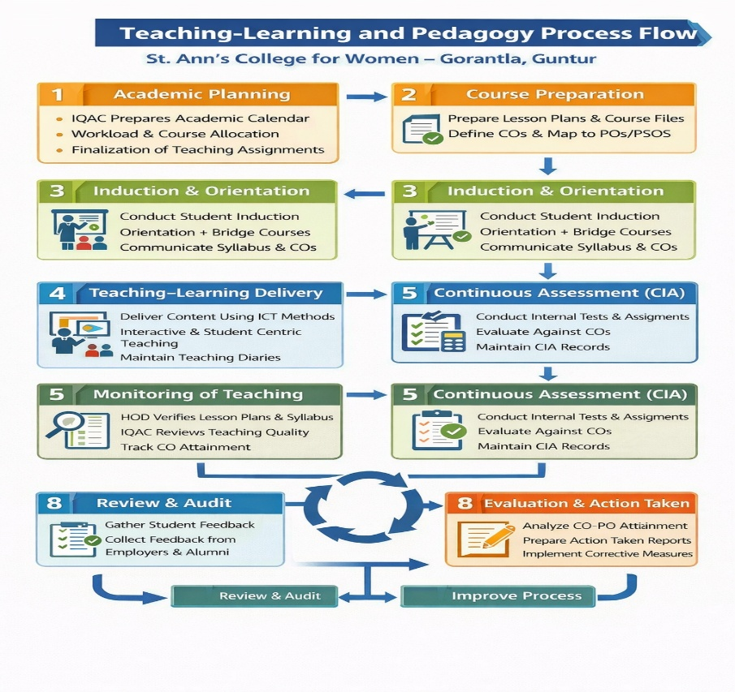
Approval and Review
- Effective Date: June 2024
- Review Cycle: Annual/Semester Based
- Responsible Authority: Principal & IQAC Coordinator

